Finals Task 3. Simple Polymorphism
Problem. Chirp and Tweet
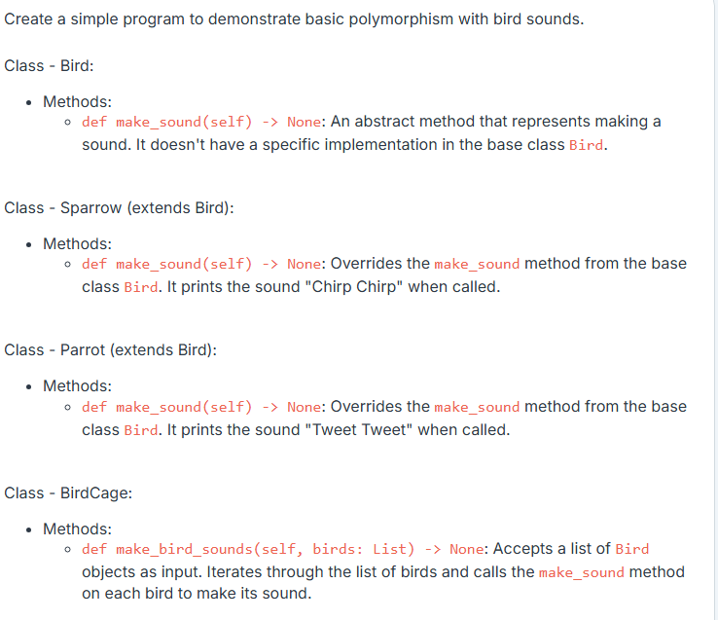
Note:
- The test cases are not outputs of your main file but of a hidden test file. Create and implement the classes instructed to test your code.
- Each class should be defined in its own file, with the file name following camelCase conventions (e.g., bankAccount.py).
TEST CASES:
